**Smart traffic management system.**

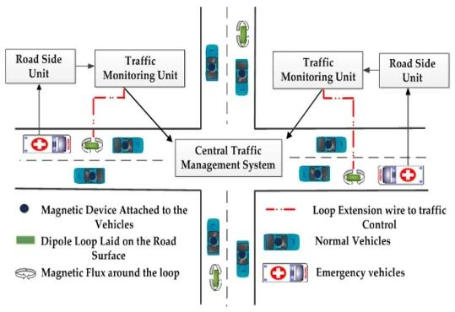

A smart traffic management system in the Internet of Things (IoT) leverages connected devices and sensors to improve traffic flow, reduce congestion, and enhance safety. Here’s how it works:

1. **Sensors and Data Collection**: IoT sensors, such as cameras, traffic lights, and road surface sensors, collect data on traffic conditions, vehicle flow, and weather conditions.
2. **Data Transmission**: These sensors transmit data to a central server or cloud platform in real-time.
3. **Data Analysis**: Machine learning and analytics algorithms process the data to identify traffic patterns, congestion, accidents, or adverse weather conditions.
4. **Traffic Prediction**: By analyzing historical and real-time data, the system can predict traffic congestion and suggest alternate routes to drivers.
5. **Dynamic Traffic Control**: Traffic signals can be dynamically adjusted based on the current traffic situation. For instance, giving more green time to the direction with heavier traffic.
6. **Emergency Response**: In the event of accidents or emergencies, the system can detect anomalies and inform relevant authorities automatically.
7. **Smart Traffic Lights**: Traffic lights can adapt their timing based on real-time traffic data, reducing wait times and improving traffic flow.
8. **Driver Assistance**: IoT devices in vehicles can communicate with the traffic management system to provide real-time navigation and traffic updates to drivers.
9. **Public Transportation Optimization**: Public transportation services can be optimized based on demand and traffic conditions, reducing delays and improving efficiency.
10. **Environmental Benefits**: Reduced congestion and smoother traffic flow can lead to lower emissions and fuel consumption.
11. **Data Sharing**: Traffic data can be shared with third-party applications and services, such as navigation apps, to further enhance the user experience.

Overall, a smart traffic management system in IoT relies on data collection, analysis, and real-time decision-making to create more efficient and safer transportation networks.

* Building an IoT traffic monitoring system is a complex task that involves various components. Here’s a high-level overview to get you started:

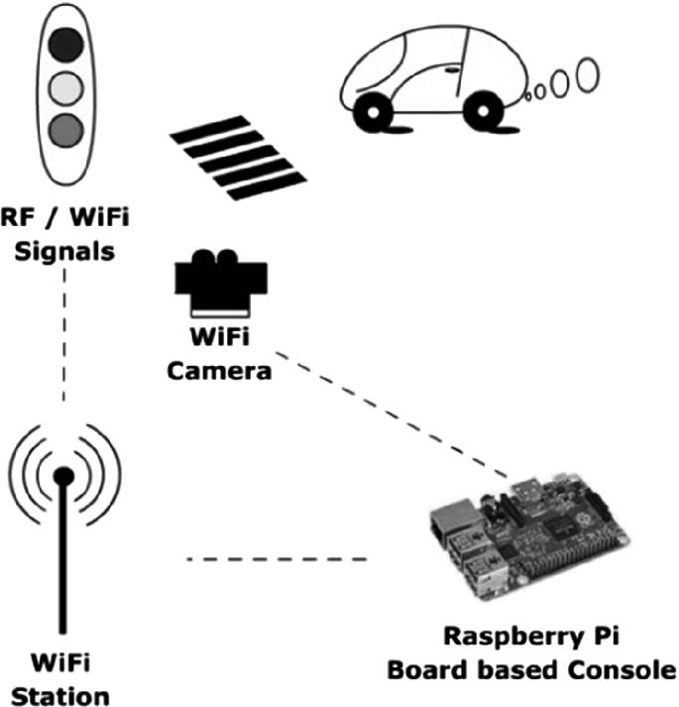

1. **Define Objectives**:

- Determine the specific goals of your traffic monitoring system, such as reducing congestion, improving safety, or optimizing traffic signals.

2. **Hardware Selection**:

- Choose the appropriate IoT hardware, including sensors, cameras, traffic lights, and communication devices. Ensure they are compatible with IoT protocols like MQTT or HTTP.

3. **Data Collection**:

- Install sensors and cameras at key locations to collect traffic-related data, including vehicle count, speed, and environmental conditions.

4. **Data Transmission**:

- Establish a network to transmit data from the sensors to a central server or cloud platform. This may involve wired or wireless connections.

5. **Cloud Platform**:

- Set up a cloud-based platform to receive, store, and process the incoming data. Services like AWS, Azure, or Google Cloud can be useful.

6. **Data Processing**:

- Develop or integrate data processing and analytics tools to analyze traffic data. Use machine learning algorithms to identify patterns and make predictions.

7. **Real-time Decision-Making**:

- Implement algorithms to make real-time decisions, such as adjusting traffic signals or alerting authorities in emergencies.

8. **User Interfaces**:

- Create user interfaces for traffic operators, city planners, and even the general public to access and visualize traffic data.

9. **Security**:

- Ensure data security by implementing encryption, access controls, and regular security audits.

10. **Integration with Traffic Infrastructure**:

- Integrate the system with traffic lights, signs, and other infrastructure components to enable dynamic control.

11. **Mobile Apps and Alerts**:

- Develop mobile apps for drivers to access real-time traffic information and receive alerts and recommendations.

12. **Scalability and Redundancy**:

- Design the system to be scalable to handle increasing data loads and include redundancy for fault tolerance.

13. **Compliance and Regulations**:

- Ensure your system complies with local regulations and privacy laws, especially regarding data collection and storage.

14. **Testing and Optimization**:

- Continuously test and optimize the system for accuracy, efficiency, and effectiveness.

15. **Feedback and Improvement**:

- Collect feedback from users and authorities to make necessary improvements and adjustments.

16. **Maintenance and Support**:

- Establish a plan for system maintenance and provide support for any issues or updates.

Remember that building an IoT traffic monitoring system is a substantial project that requires expertise in IoT, data analytics, and software development. Collaboration with relevant authorities and stakeholders is essential to ensure the success of the system.

* To deploy IoT devices in strategic locations to monitor traffic conditions, follow these steps:

1. **Site Selection**:

- Identify key locations for deploying IoT devices, considering factors such as traffic congestion, accident-prone areas, and intersections. Consult with traffic experts and city planners for guidance.

2. **Hardware Selection**:

- Choose the appropriate IoT hardware, including sensors, cameras, and communication devices. Ensure they are durable, weather-resistant, and suited for the specific location.

3. **Power Supply**:

- Determine the power source for your devices. Options include mains power, solar panels, or batteries, depending on the location.

4. **Connectivity**:

- Establish a reliable communication network, which can be cellular, Wi-Fi, or LoRaWAN, to transmit data from the devices to your central server or cloud platform.

5. **Installation**:

- Install the IoT devices securely and at an appropriate height for cameras or sensors to capture data effectively. Ensure they are protected against vandalism and environmental conditions.

6. **Configuration**:

- Configure the devices to collect and transmit data as per your requirements. Set up parameters for data sampling intervals and communication protocols.

7. **Data Transmission**:

- Test the data transmission from the devices to ensure that data is being sent correctly and consistently.

8. **Data Storage and Processing**:

- Set up a cloud platform or local server to receive, store, and process the incoming data from these devices.

9. **Data Validation**:

- Implement data validation processes to ensure the accuracy and integrity of the data collected by the devices.

10. **Security Measures**:

- Implement security measures to protect the devices from unauthorized access and tampering. This includes securing communication channels and using encryption.

11. **Remote Monitoring**:

- Set up remote monitoring capabilities to check the status and health of the deployed devices.

12. **Testing**:

- Conduct extensive testing to verify the devices’ functionality, data accuracy, and communication reliability.

13. **Data Analysis**:

- Implement data analytics tools to analyze the collected traffic data and derive meaningful insights.

14. **Integration**:

- Integrate the data from these devices with your traffic management system for real-time decision-making.

15. **User Access**:

- Develop user interfaces for traffic operators and city planners to access and visualize traffic data.

16. **Maintenance Plan**:

- Create a maintenance plan that includes regular inspections, updates, and repairs for the IoT devices.

17. **Compliance**:

- Ensure compliance with local regulations and privacy laws in your deployment.

18. **Documentation**:

- Maintain detailed documentation of device locations, configurations, and maintenance records.

19. **Scaling**:

- Plan for future expansion and scalability of your deployment as traffic monitoring needs evolve.

By following these steps, you can strategically deploy IoT devices to effectively monitor traffic conditions and contribute to a smarter traffic management system.

* Certainly, to develop a Python script for IoT devices to send real-time traffic data to a traffic information platform, you’ll need to use a protocol like MQTT for communication. Here’s a basic example using the Paho MQTT library in Python. You’ll need to adapt this script to your specific hardware and sensors.

```python

Import paho.mqtt.client as mqtt

Import json

Import random

Import time

# MQTT Broker information

Broker_address = “mqtt.example.com”

Port = 1883

Topic = “traffic_data”

# Simulated traffic data (replace with actual sensor data)

Def generate_traffic_data():

Data = {

“location”: “Intersection A”,

“vehicle_count”: random.randint(0, 100),

“average_speed”: random.uniform(0, 60),

“timestamp”: int(time.time())

}

Return json.dumps(data)

# MQTT callback when the client is connected

Def on_connect(client, userdata, flags, rc):

Print(f”Connected with result code {rc}”)

# Create an MQTT client

Client = mqtt.Client()

Client.on_connect = on_connect

# Connect to the MQTT broker

Client.connect(broker_address, port, 60)

Try:

While True:

# Simulate traffic data

Traffic_data = generate_traffic_data()

# Publish data to the MQTT topic

Client.publish(topic, traffic_data)

Print(f”Published: {traffic_data}”)

# Adjust the time interval as needed

Time.sleep(5)

Except KeyboardInterrupt:

Client.disconnect()

```

In this script:

1. Replace `broker_address` with the address of your MQTT broker.

2. Update the `generate_traffic_data` function with your actual sensor data collection logic.

3. Modify the `topic` to match the topic where your traffic data should be published.

Remember that you’ll need to install the Paho MQTT library using `pip install paho-mqtt` to use this script. Additionally, adapt the script to run on your specific IoT device and sensors, and handle any data transmission specifics required by your traffic information platform.